

PROPOSAL FOR CAR PARKING QUEUE SYSTEM MODELING AND SIMULATION



Group C1.1 TA: Maha Farghaly

Ziad Khaled Hamdy 20210489 Mohamed Alaaeldin 20213854

Ahmed Yasser Ahmed 202103939

# Problem Formulation:

The increasing number of vehicles in urban areas has led to a significant demand for efficient car parking systems. The current manual and semi-automated systems often result in long.

queues, inefficient use of space, and increased waiting times. The problem at hand is to develop a model and simulation of a car parking queue system that can optimize space utilization,

reduce waiting times and improve overall efficiency.

# Setting of Objectives:

The primary objectives of this project are:

* To develop a model that accurately represents the dynamics of a car parking queue system.
* To simulate various scenarios to understand the behavior of the system under different conditions.
* To identify strategies for optimizing space utilization and reducing waiting times.
* To provide a tool that can assist in the design and management of car parking systems.

# Overall Plan:

The project will be carried out in the following phases:

* Phase 1: Literature review and data collection
* Phase 2: Model conceptualization and development
* Phase 3: Simulation and analysis
* Phase 4: Optimization and strategy formulation
* Phase 5: Documentation and presentation of results

# Model Conceptualization:

# **Multi-Server Queue System:**

# In a multi-server queue system, several servers simultaneously attend to incoming cars. The waiting time for cars and service time can be described using models like the M/M/c queuing system, where:

# **Arrival Rate (λ)**: Rate at which cars arrive at the parking queue.

# **Service Rate (μ)**: Rate at which cars are served.

# **Number of Servers (c)**: The number of servers attending to cars.

# The average waiting time for a car in this system can be calculated using queueing theory formulas specific to the M/M/c model. Factors like the number of servers and their efficiency significantly impact the waiting time and service duration.

# **Event Scheduling:**

# Event scheduling involves managing and optimizing the sequence of events to minimize waiting times and increase efficiency. In a parking queue system, event scheduling can involve:

# Determining optimal times for parking lot maintenance or reorganization to reduce congestion.

# Scheduling the entry and exit of cars to minimize waiting times during peak hours.

# Implementing algorithms or strategies to manage special events or high-traffic periods efficiently.

# Event scheduling algorithms like Shortest Job Next (SJN), First-Come-First-Served (FCFS), or Round Robin can be adapted to manage the entry and exit of cars, thereby affecting waiting times.

# **Classical Inventory:**

# Classical inventory models involve managing stock levels to meet demand while minimizing costs. In a parking queue system:

# Inventory can refer to the number of available parking spaces.

# Waiting time for cars can increase when there's insufficient space (low inventory) during peak hours.

# Effective inventory management strategies like Economic Order Quantity (EOQ) or Just-In-Time (JIT) can optimize parking space utilization, reducing waiting times for cars.

# **M and N Inventory:**

# The M/N inventory models extend the classical queuing systems to situations where there are finite waiting spaces or capacity constraints. In the context of a parking queue system:

# indicates a system with finite capacity 'N', where 'c' servers handle the cars, and the maximum waiting space is limited.

# represents a system with an unlimited number of servers ('M') and finite capacity 'N' for waiting cars.

# In summary, waiting times for cars and service times in a parking queue system are influenced by various factors such as the number of servers, event scheduling strategies, inventory management models, and capacity constraints. Analyzing these aspects helps optimize the system's efficiency and minimize waiting times for cars.

# Data Collection:

In Multi server:

number of customers input by user.

Inter Arrival Time is generated random numbers from java

Arrival Time is taken from probability table.

In Classical Inventory:

number of days this taken as input by user

Day Type is generated from random numbers from java

the price for each ticket for each car taken from user

the price for sell ticket is taken by user.

demand is generated from random numbers from java

Price the number of purchase of tickets it takes from user

Price for buy for each tickets taken by from user

M , N Inventory:

number of inventory start taken as input by user.

The number of cycle length taken as input by user

The number of weekly orders is taken as input by user.

The number of conditions is taken as input by user.

The number of days work is taken as input by user.

The demand is generated from random numbers from java

Event Scheduling:

Number of simulation length is taken by user

Number of conditions for F is taken by user

Inter Arrival Time is generated randomly from java

Service Time is generated randomly from java

Model translation:

Model translation is Implemented.

Verified and Validated:

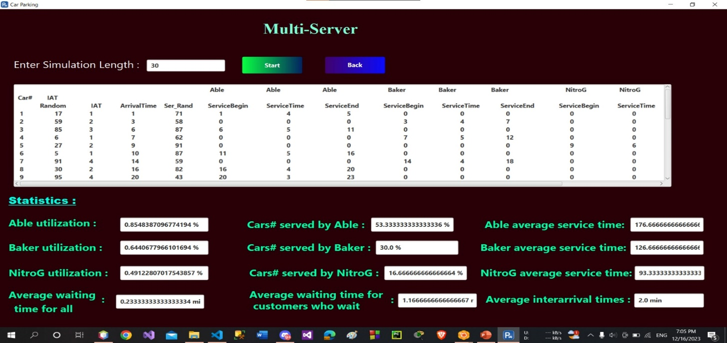This phase involves verifying the requirements and specifications of the parking queue system. It includes confirming the necessity, scope, and desired outcomes of the system.

In this Case the simulation is sound and effective with an average waiting time of one minute

In this Case the simulation is sound and effective with an

average waiting time of one minute

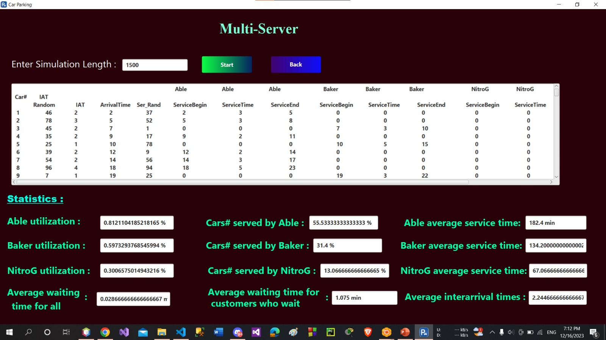

In this case, the average waiting time is a minute and some

seconds because the number of customers is very large.

In this case, the total lost profit is 10.2$ and the

Store had the required number; its profit would have been 10.2$

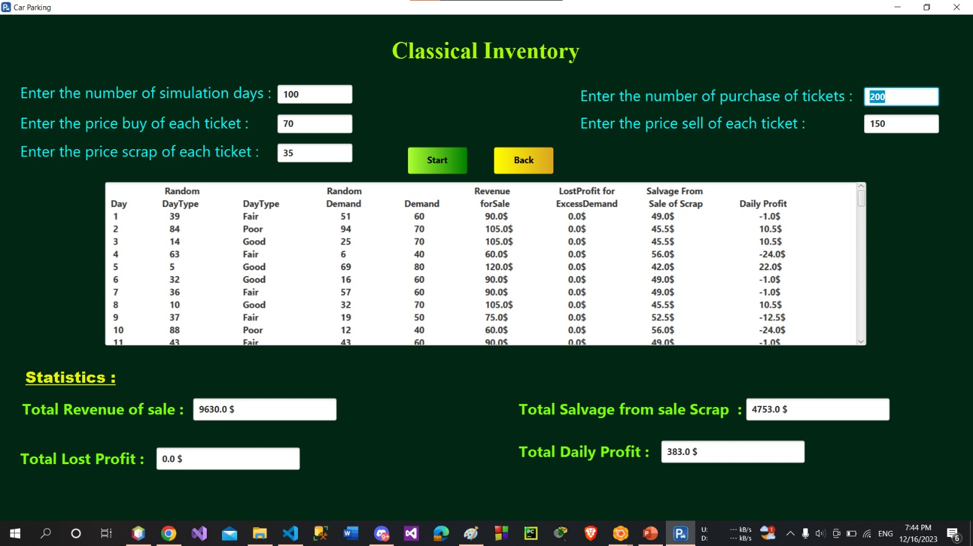

In this case, the total lost profit is 0 $ and the Store has provided all orders to customers.

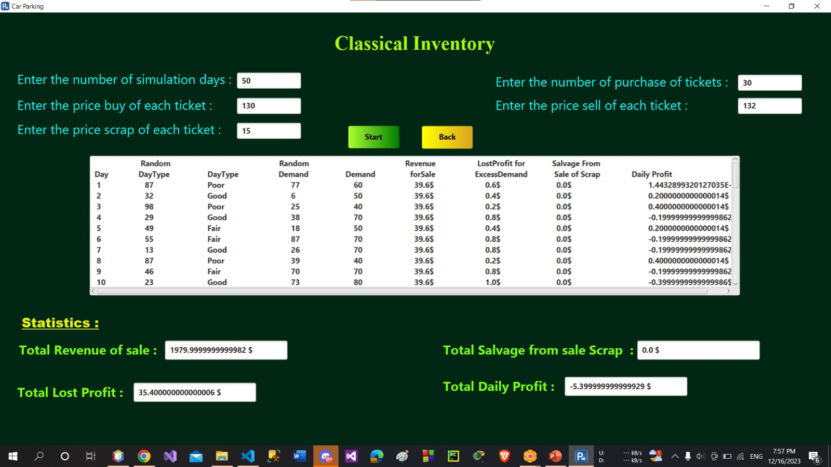

In this case, there will be a total loss of 5$ because the buying price is close to the selling price

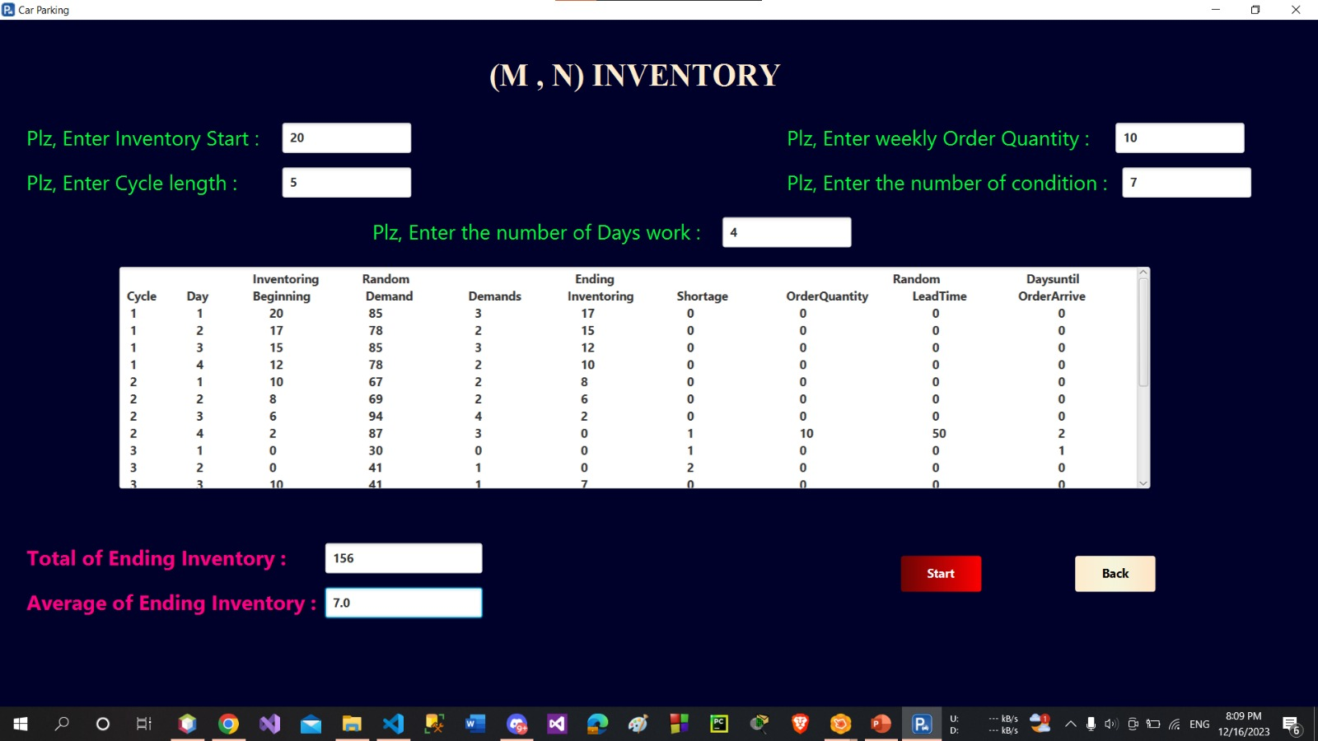

In this case, the total ending inventory is relatively high 156, while the average ending inventory is still somewhat low 7. This suggests that the system is not as efficient as it could be, but it is still able to meet customer demand without having a huge backlog of cars.

in this case, A relatively high total ending inventory 169 suggests that the parking lot might be overstocked, on average.

The average ending inventory of 4.0 cars is lower than the total ending inventory, indicating that the parking lot is not constantly full.

in this case, A very high total ending inventory 1891 suggests that the parking lot is significantly overstocked.

The average ending inventory of 18.0 cars is lower than the total ending inventory, indicating that the parking lot is not constantly full.

in this case, The average response time in the simulation is 3.2 minutes. This means that on average, it takes 3.2 minutes for a customer to enter the system and then depart the system.

The observed proportion total of customers who spent 5 minutes or more in the system is 0.16%. This means that out of all the customers who were simulated.

The average response time is 4.4 minutes. This means that on average, it takes 4.4 minutes for a customer to enter the car park and then depart.

The observed proportion total of customers who spent 5 minutes or more is 0.8%. This means that out of all the customers who were stimulated, 0.8% of them spent minutes in the car park.

The average response time is 5.1875 minutes. This means that on average, it takes 5.1875 minutes for a customer to enter the car park and then depart.

The observed proportion total of customers who spent 5 minutes or more is 0.0%. This means that the simulation ended quickly and without expectations of waiting.

Experimental Design:

In the context of a parking queue system, the experimental design aims to bolster operational efficiency by diminishing average waiting times for customers and amplifying the overall service throughput within a real-world parking environment.

multi server : we run simulation 2 times with change simulation length and we will observe waiting times changes by add new server for simulation system

Classical inventory : we run simulation 2 times with change number of price of buying and price of selling and number for start , simulation days

M , N inventory : we run simulation 2 times with change number

Of inventory start , cycle length and quantity and the number of condition.

Event scheduling : we run simulation 2 times with change number of customers and conditions.

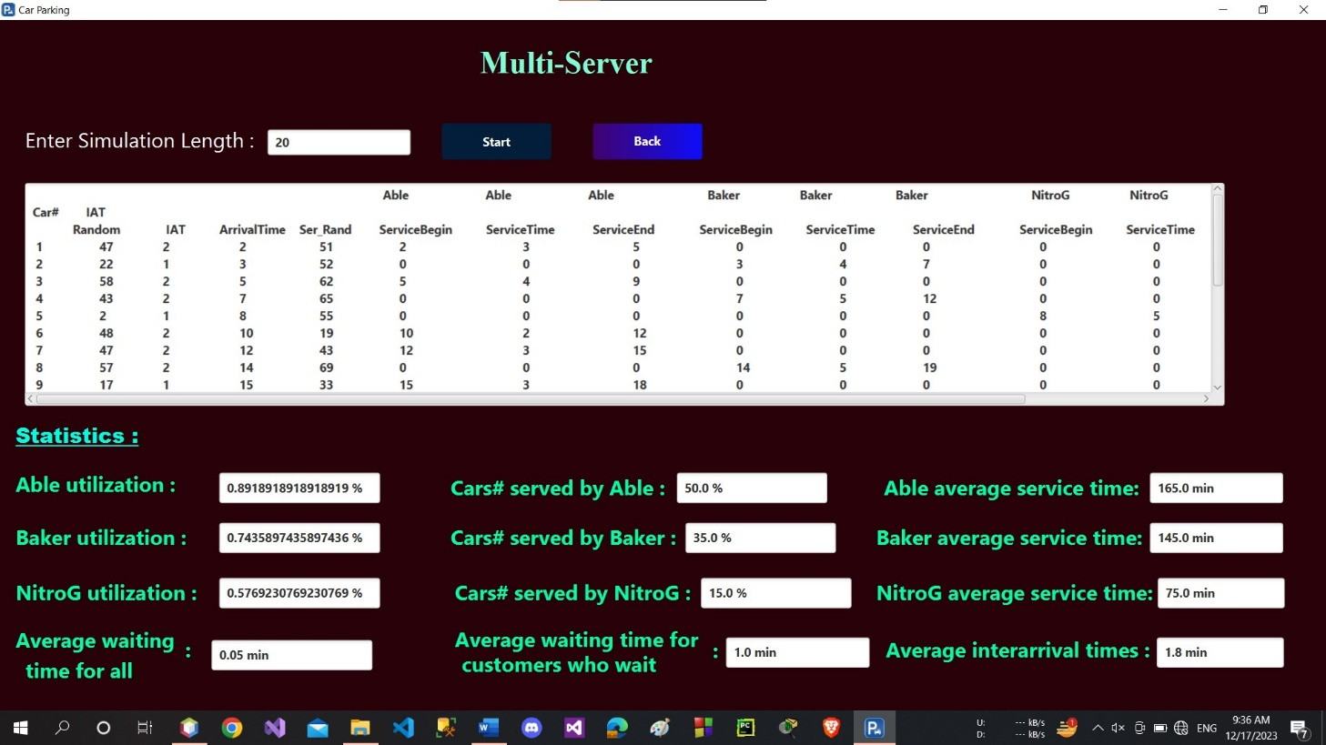Production runs and Analysis:

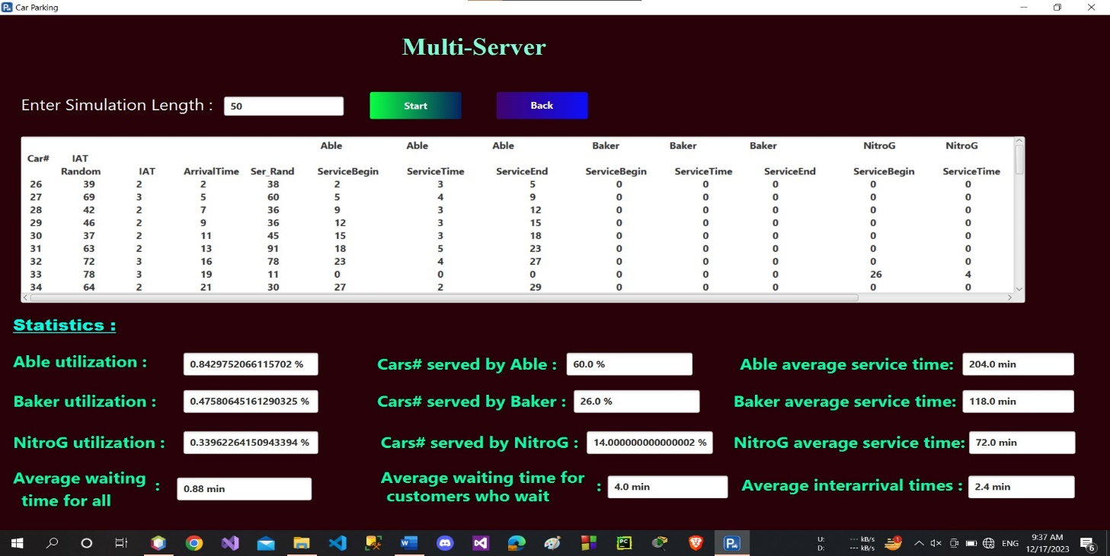In this figure, the average waiting time is 1 min for each customer and this is Appropriate for good system simulation

In this figure, the average waiting time is 4 min for each customer because every car take a lot of time in each server

And the inter arrival time is close.

in this figure we have total lost profit is 0.0$

This means the system had fulfilled all customer orders and there is no inventory shortage. And the number of purchases tickets is Appropriate.

so, there is no lost profit.

In this figure, we have a lost is 35.4$

This means the system does not fulfill all customers' orders because the stock does not have the required number of orders. And the number of purchases tickets is little.

So, we have lost profit.

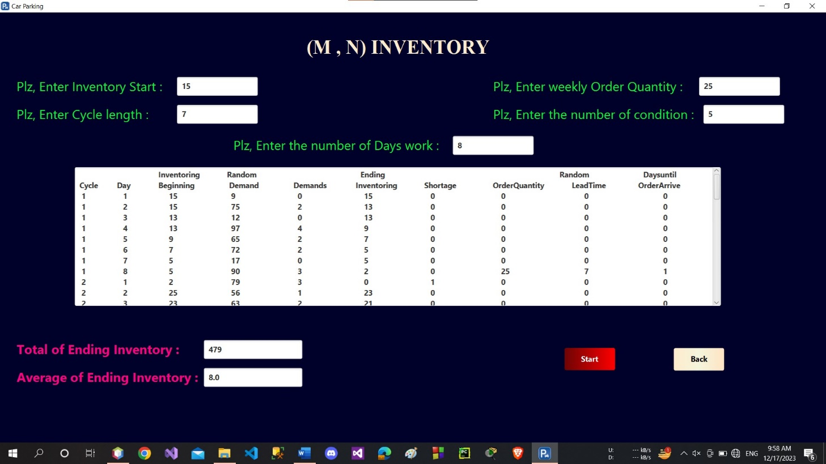

In this figure, relatively high total ending inventory 479 suggests that the parking lot might be overstocked, on average.

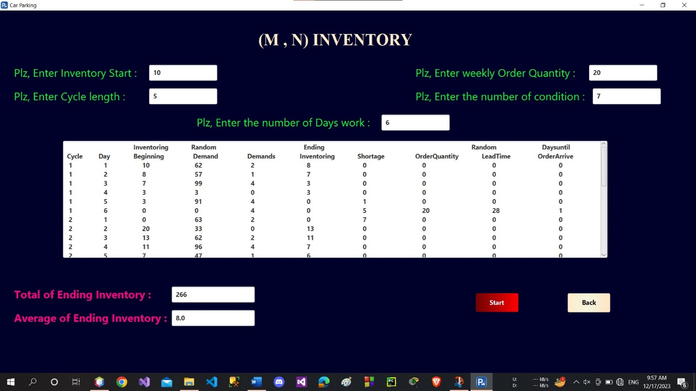The average ending inventory of 8.0 cars is lower than the total ending inventory, indicating that the parking lot is not constantly full

In this figure, relatively high total ending inventory 266 suggests that the parking lot might be overstocked, on average.

The average ending inventory of 8.0 cars is lower than the total ending inventory, indicating that the parking lot is not constantly full

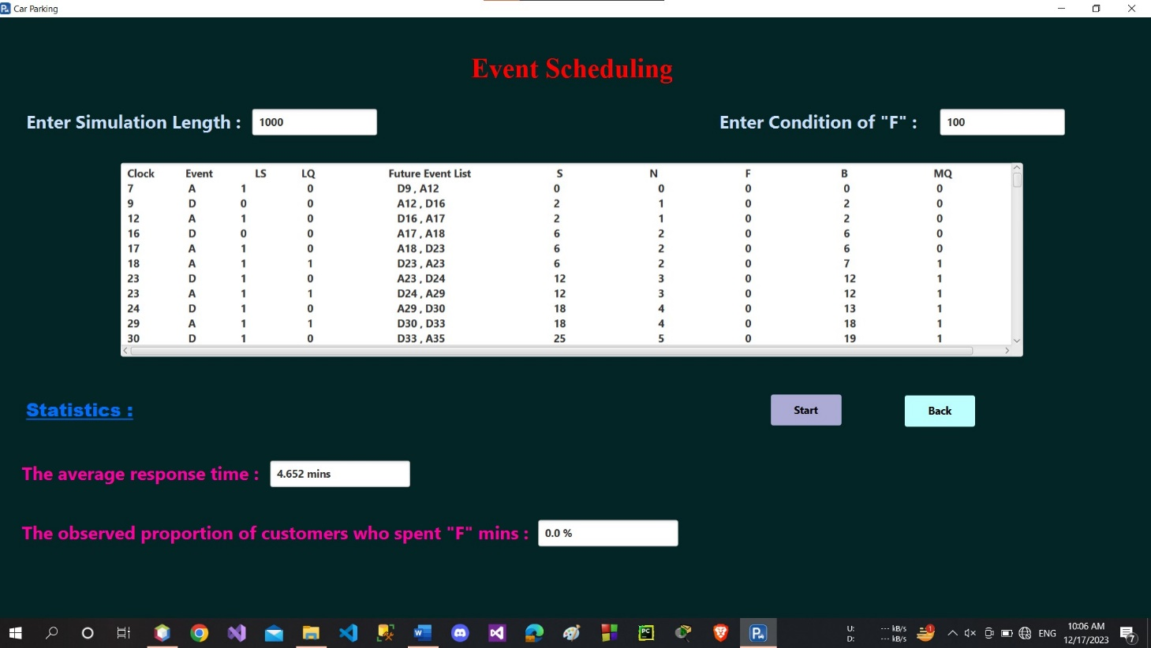

In this figure, The average response time is 4.652 minutes. This means that on average, it takes 4.652 minutes for a customer to enter the car park and then depart.

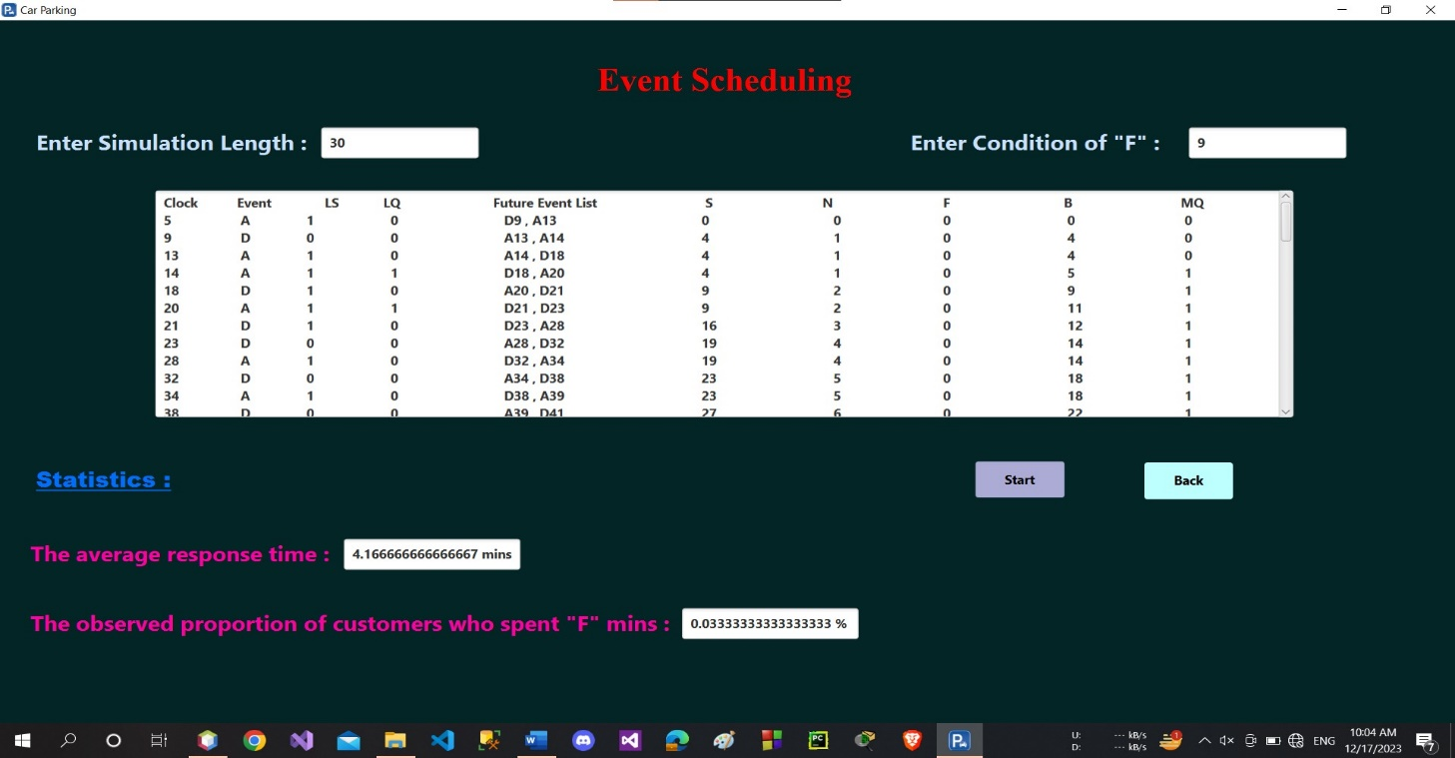The observed proportion total of customers who spent 5 minutes or more is 0.0%. This means that the simulation ended quickly and without expectations of waiting

In this figure, The average response time is 4.1666 minutes. This means that on average, it takes 4.1666 minutes for a customer to enter the car park and then depart.

The observed proportion total of customers who spent 5 minutes or more is 0.033333%. This means that the simulation ended with a few waiting times

More Run:

This stage involves additional testing and fine-tuning of the system. It may include conducting more trials, gathering feedback from test users or stakeholders, and making necessary adjustments or optimizations to enhance the system's performance and reliability.

Documentation and reporting:

Throughout the development and implementation process, comprehensive documentation is created. This includes technical specifications, user manuals, system architecture diagrams, and reports detailing the system's development stages, testing results, and any modifications made.

Implementation:

The final stage involves deploying the parking queue system in the intended environment. This includes installation, configuration, and integration with existing infrastructure if applicable. Training sessions may also be conducted for users or administrators to ensure smooth adoption and operation of the system.